# Handover Document

# 1. Project Overview

This project aims to develop a sonar system capable of measuring underwater range to three beacons, expanding on existing hardware that supports one beacon.  The project involves upgrading the system, programming a microprocessor for precise timing, validating performance through experiments, and implementing a real-time data collection system integrating ranging signals, RTK-GPS, and IMU, mounted on a boat.

# Issues & Lessons Learned

During the project's advancement, the team encountered some challenges and gained valuable experience from them. The initially used pulse communication protocol was overly complex and difficult to implement stably. Later, upon the customer's suggestion, we simplified it to an 8-bit encoding method, which significantly improved the communication effect and reduced the development burden. Meanwhile, when the Nucleo board was relied on for hardware testing in the early stage, the test results were unstable and were greatly affected by the environment. Eventually, the simulation on the PC side was changed, which effectively improved the debugging efficiency and test reliability. After the team was grouped by function in the later stage of the project, there were also problems such as untimely coordination and unclear task connection for a time. To address this, we established a weekly synchronous reporting mechanism and unified the document template, thereby enhancing the team's collaboration efficiency and information transparency.

# 3. Key Design Decisions

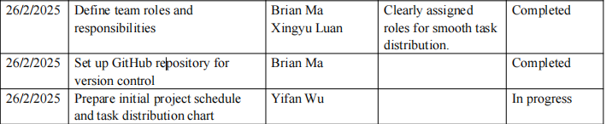

In the early stage of the project, our team established the key task allocation for each member in the first meeting, such as project management, engineering development, etc., to ensure the efficiency of task advancement. Subsequently, a GitHub version control repository was established for code collaboration.

The decisions made at this stage have laid a solid foundation for the orderly development of subsequent work.

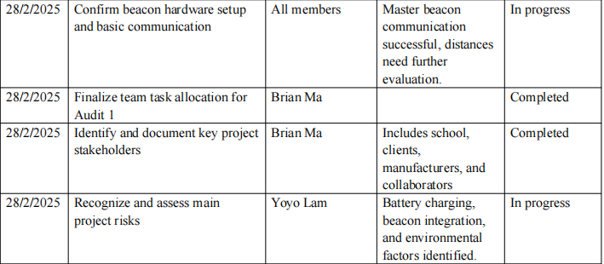

In the second meeting, we made several decisions related to technical directions and risk control:

The basic communication of the beacon hardware was successfully achieved, paving the way for the subsequent signal test. The key stakeholders of the project (schools, customers, hardware suppliers, etc.) have been identified; The main risk points were identified, such as battery life, the difficulty of beacon integration and the influence of environmental factors, and the mitigation plan was formulated led by Yoyo Lam.

These decisions enable us to manage potential risks in advance.

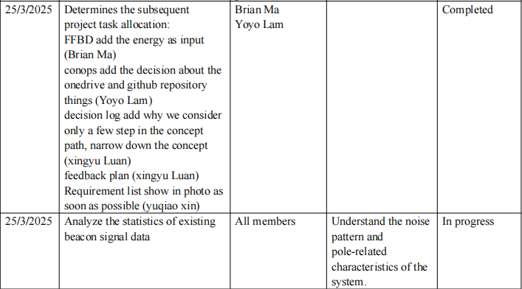

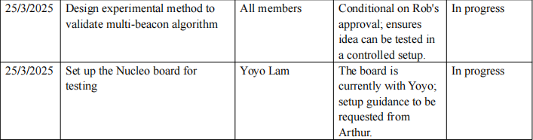

In the mid-term stage, we focus on the path of algorithm innovation and verification:

The team proposed a multi-beacon communication scheme without modifying the hardware conditions, such as: control signal transmission/non-transmission, gain adjustment or ID encoding; Meanwhile, the experimental verification route was planned, including how to build a controllable verification environment after Rob's approval;

I also clarified in this meeting why we chose to focus on only a few steps to design the algorithm path and supplemented this idea into the decision log.

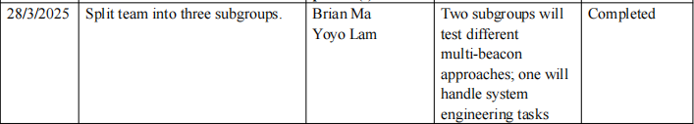

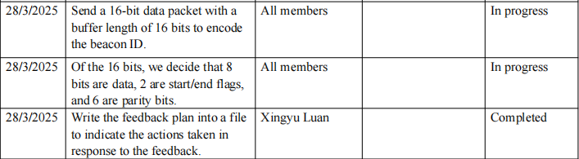

The team was divided into three groups according to functions: two for the experimental verification of different algorithms, and one focused on the integration of systems engineering; It was decided to use 16-bit data packets to transmit the beacon ID and further divide it into 8-bit data, 2-bit flag bits and 6-bit check bits to enhance the robustness of communication.

These decisions have greatly enhanced the organizational efficiency of the experiment and the scalability of the system.

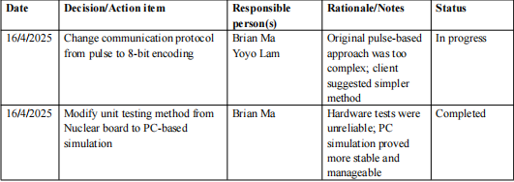

The original communication method based on pulse was complex and unstable, and it was decided to change to 8-bit encoding for implementation.

The initial test on the Nucleo hardware board was not satisfactory. Therefore, the simulation test was changed to be conducted on the PC side, which is more stable and easier to debug.

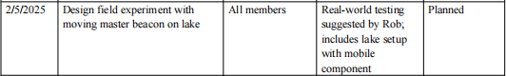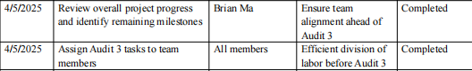

In the later stage of the project, the team focused on task completion and on-site experiment preparation:

Design a field experimental scenario for moving the main beacon on the lake surface and simulate the real environment as suggested by Rob.

The specific tasks and time nodes of all members before Audit 3 have been clarified;

# Key Stakeholders & Resources

Our main skateholders are Rob and Iain. We mainly communicate with them every week to determine if we are on the right track, and also listen to their suggestions and plans reasonably. The main resources are one main beacon and three sub-beacons, a computer. The experimental site in the early stage of the project is a water tank, and in the later stage of the project, it is a lake.

# 5. Road map

Since the project was launched in February 2025, the team has steadily advanced various tasks in phases. In the early stage of the project (the first two weeks), we completed the team formation, role division, the setup of the GitHub version control system, as well as the initial task plan and time arrangement. From the 3rd to the 5th week, focus on the establishment and testing of communication between the primary beacon and sub-beacons, gradually clarify the system design architecture, and at the same time identify the main risk points and propose countermeasures. From the 6th to the 8th week, the team optimized the communication protocol, shifting from complex pulse signals to a more concise 8-bit encoding, which enhanced the system stability. This stage also includes the exploration of multi-beacon algorithms and the design of Nucleo plate simulation experiments. From the 9th to the 10th week, the team began to design the field test plan, including the scheme of testing mobile beacons on the lake surface. At the same time, the task allocation and progress confirmation before Audit 3 were completed.

Feasible route suggestions for the future include further improving the robustness of the multi-beacon algorithm and introducing SLAM technology to achieve environmental perception and positioning; Continuously optimize communication stability and power consumption management; Finally, the deployment and practical verification of the system in a complex environment are achieved.

# Supporting Materials